Network Monitoring
VPC, Subnets, IGW, NAT GW, NACL

Saskatchewan Polytechnic
CNET-123-T02 Introduction to Networking and Cloud Services
Prepared By:
Md Alamgir Hossain
Contents
Part1-Creating A VPC named BIS-Lab5-VPC 2
VPC Creating 2
1.1 Start from Scratch, there is only one default VPC before starting Lab5. 2
1.2 Creating VPC named BIS-Lab5-VPC from scratch. 3
1.3 VPC created. 3
Internet Gateway Creation 3
1.4 Start from scratch, no IGW before starting Lab5. 3
1.5 Creating Internet Gateway named BIS-Lab5-IGW. 4
1.6 IGW created. 4
1.7 Attaching IGW with VPC 4
1.8 IGW attached with BIS-Lab5-VPC 4
Part 2: Creating 6 subnets: 4
2.1 No subnets before starting this assignment. 4
2.2 creating subnets and repeating the process to create all six subnets. 5
2.3 Six subnets created. 6
Part3- Create NAT Gateway 7
3.1 No NAT Gateway before starting lab5 7
3.2 Creating NAT Gateway 7
3.3 NAT Gateway created named BIS-Lab5-NAT-GW 7
3.4 Configure the Public Route Table (DMZ) 8
3.4.1 Edit default routing table (BIS-Lab5-PUBRT): 8
3.4.2 change destination to 0.0.0.0/0 and destination to igw-01346ac63b97c4642 (My Internet Gateway) 8
3.4.3 Edit subnet association (DMZ subnets) to associate them with public routing table as it can talk with IGW through public routing table. 8
3.5 Configure the Private Route Table (App & DB): 9
3.5.1 Creating routing private routing table named BIS-Lab5-PRIVRT 9
3.5.2 Private routing table created. 9
3.5.3 Edit Routes to destination NAT Gateway (nat-0d7491f9a0bdcf8ca). 9
3.5.4 Routes edited for private routing table. 10
3.5.5 Edit subnet association for remaining network (AppLayer and DBLayer). 10
3.5.6 Routing Table Configuration 10
Part 4: Creating NACLs 11
4.1 Creating DMZ NACL for Demilitarized Zone subnets 11
4.2 Creating App-NACL for AppLayer subnets 11
4.3 Creating DB-NACL for DBLayer subnets. 11
4.4 All NACL before editing subnet association. 11
Part 5: Subnet Association with NACL 12
5.1 Associated DMZ-NACL with DMZ Subnets. 12
5.2 Associated APP-NACL with APP subnets. 12
5.3 associated DB-NACL with DB subnets. 12
Part 6: Questions and Answers 13

Part1-Creating A VPC named BIS-Lab5-VPC

VPC Creating

1.1 Start from Scratch, there is only one default VPC before starting Lab5.
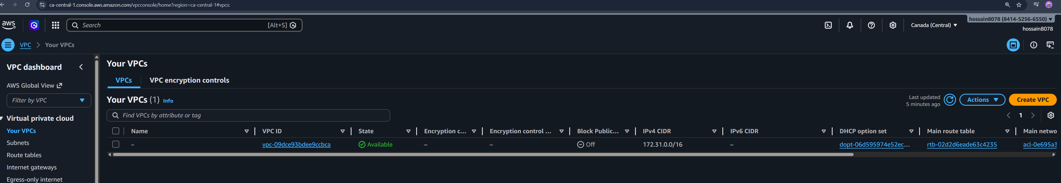

1.2 Creating VPC named BIS-Lab5-VPC from scratch.
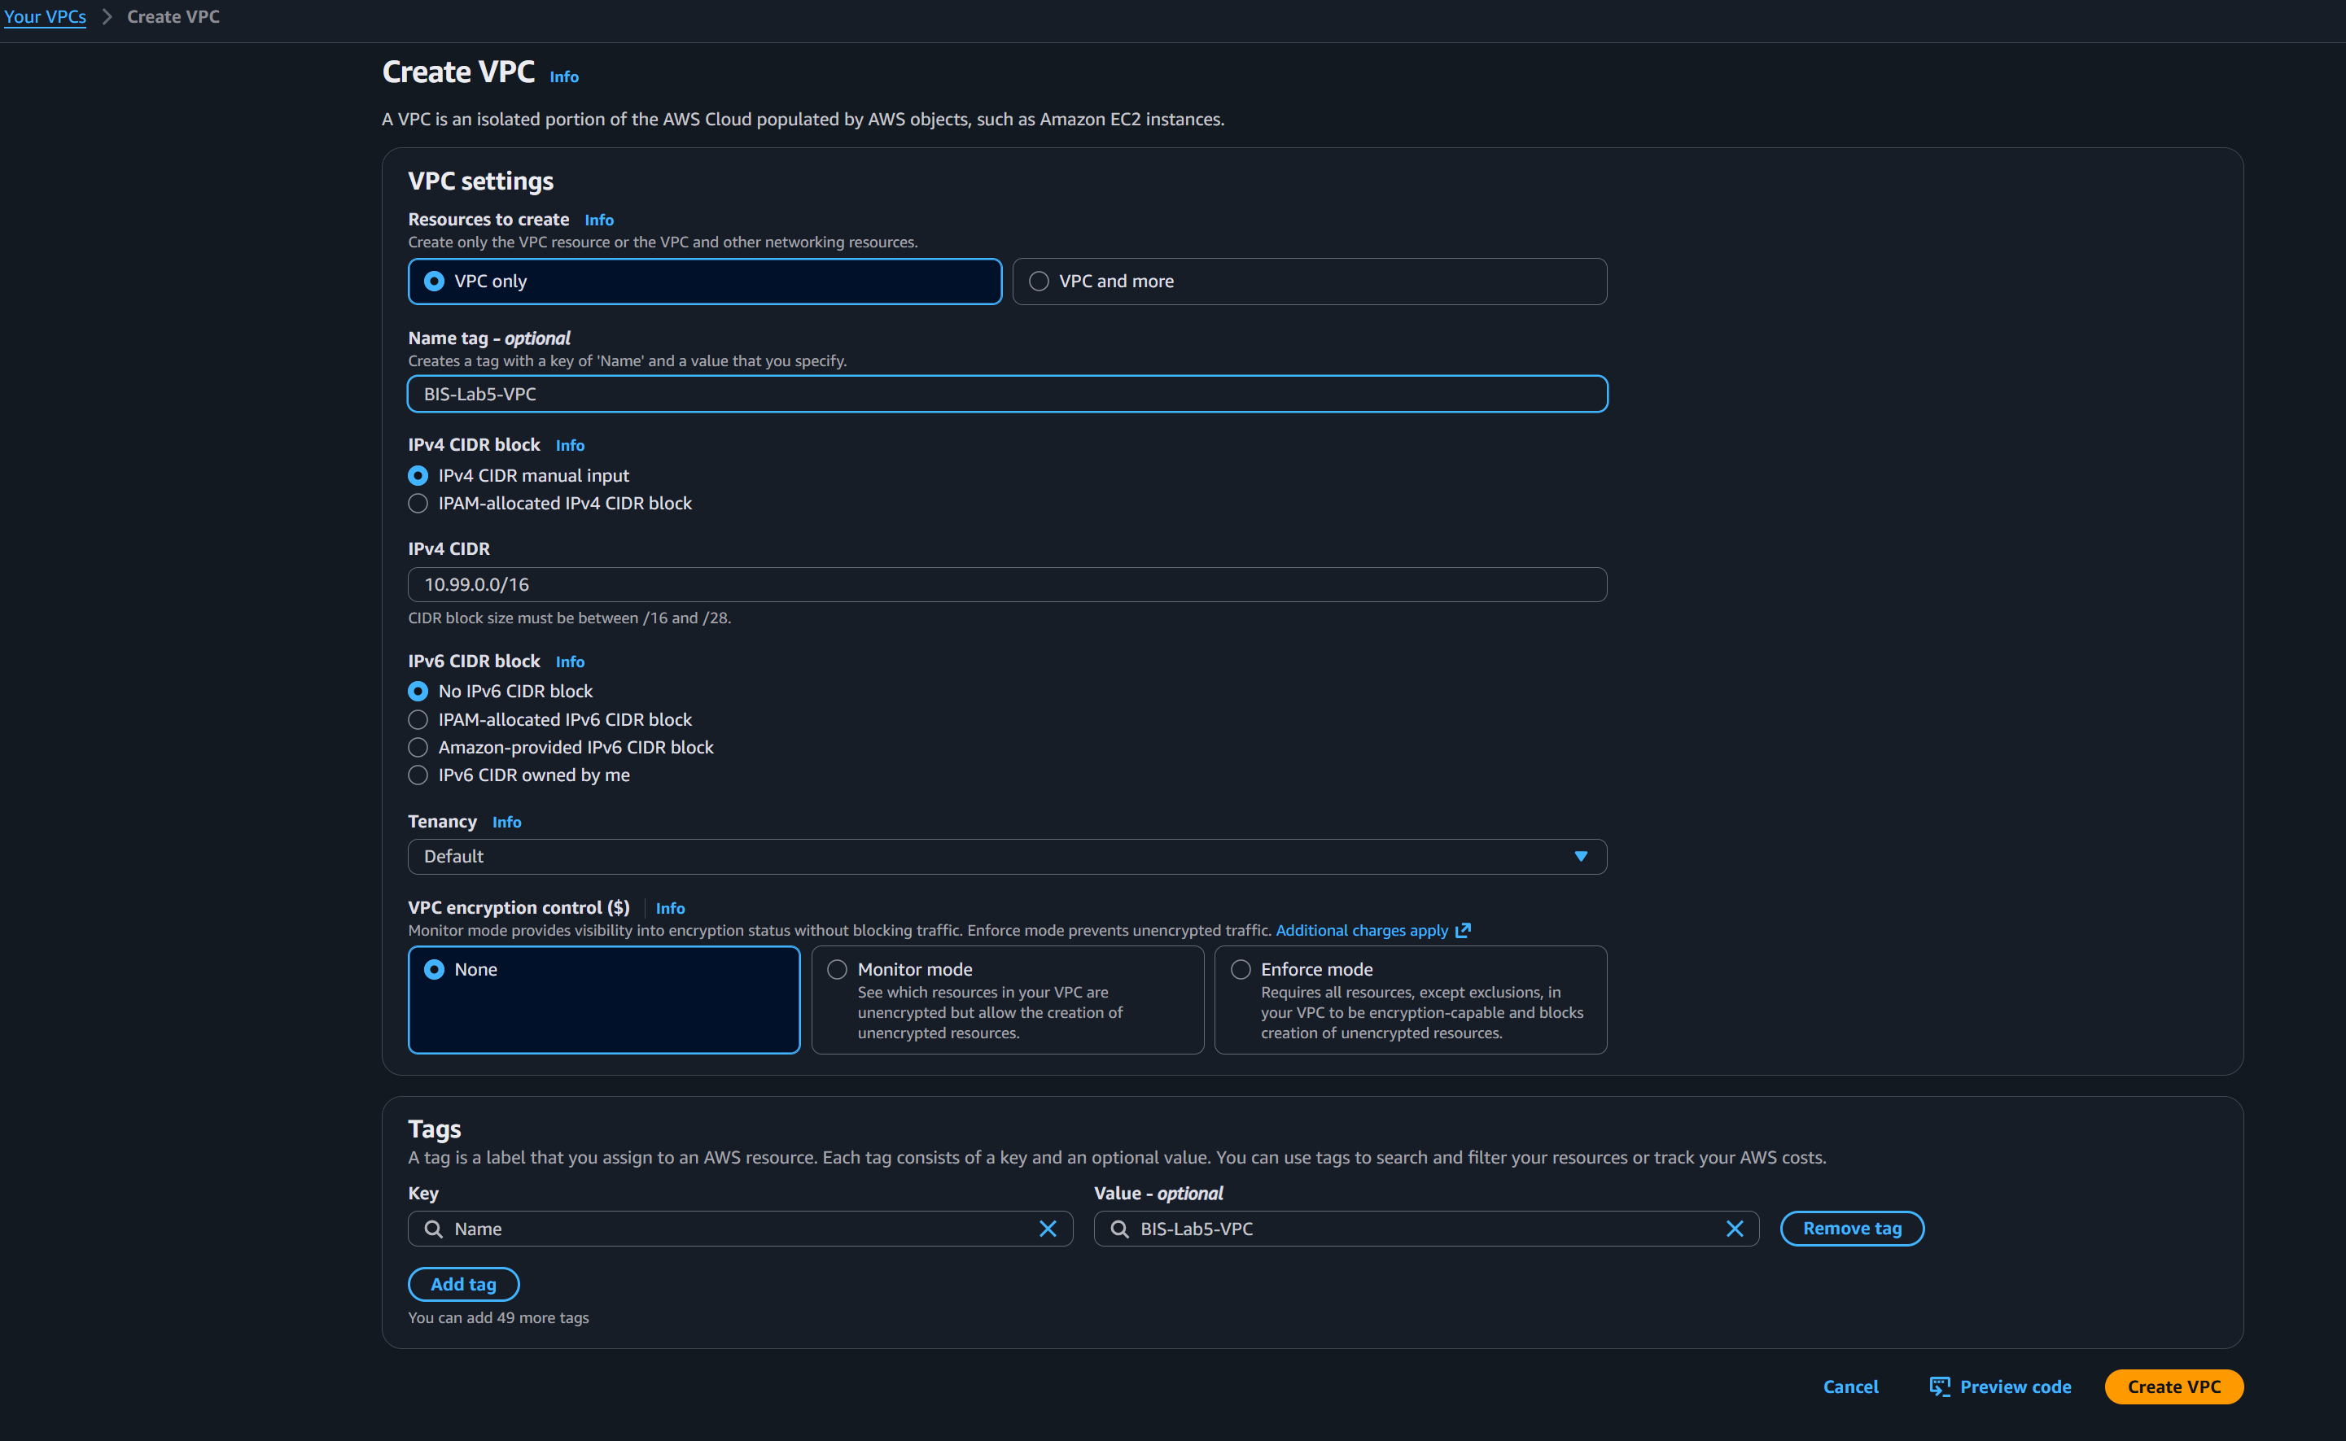

1.3 VPC created.
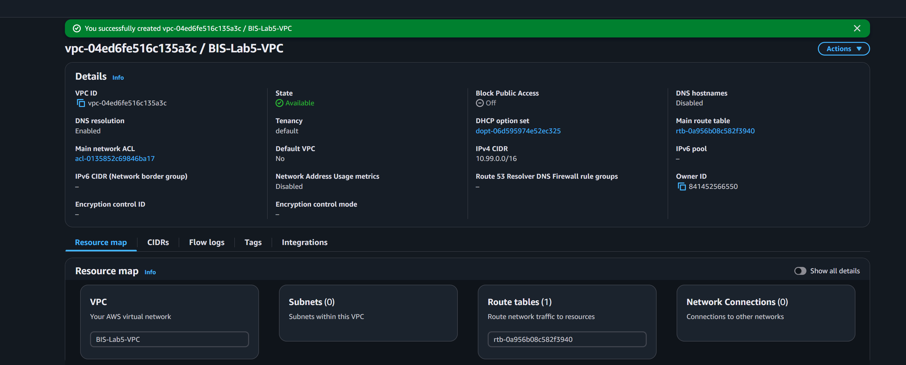

Internet Gateway Creation

1.4 Start from scratch, no IGW before starting Lab5.
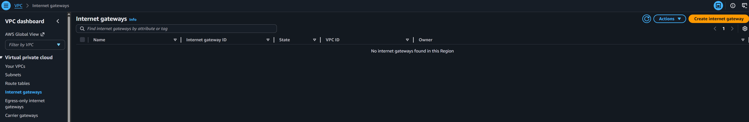

1.5 Creating Internet Gateway named BIS-Lab5-IGW.
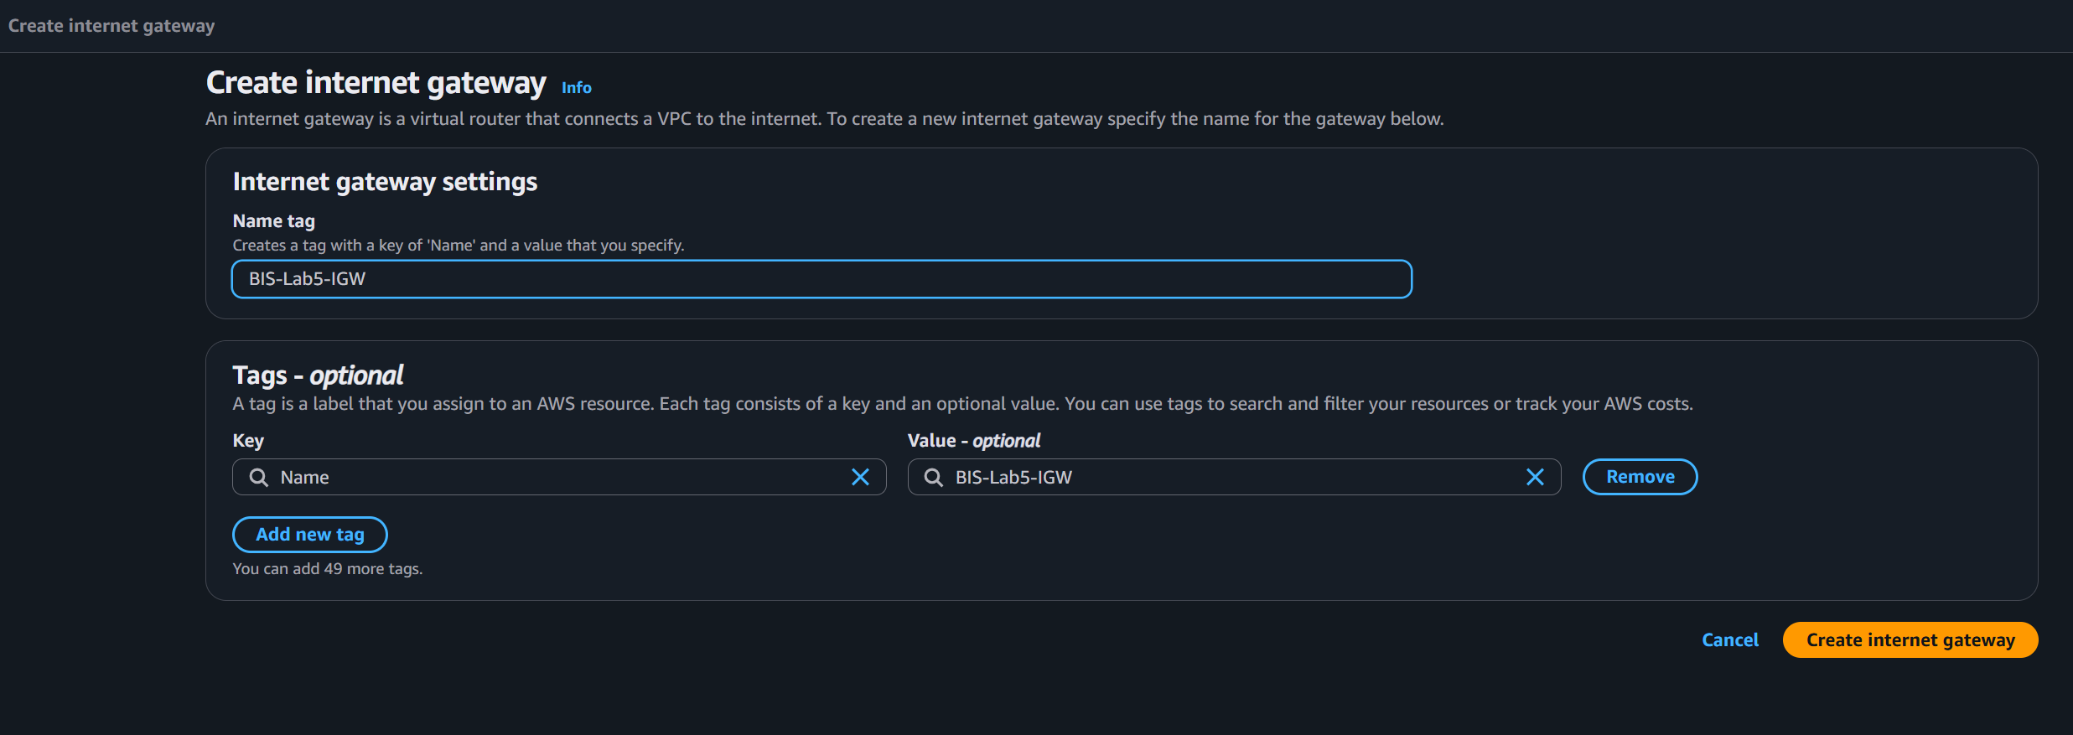

1.6 IGW created.
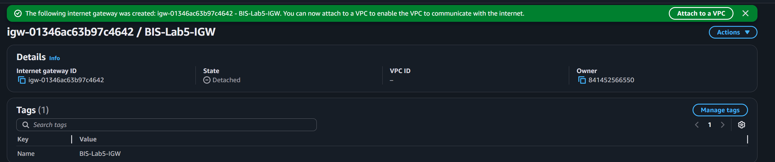

1.7 Attaching IGW with VPC
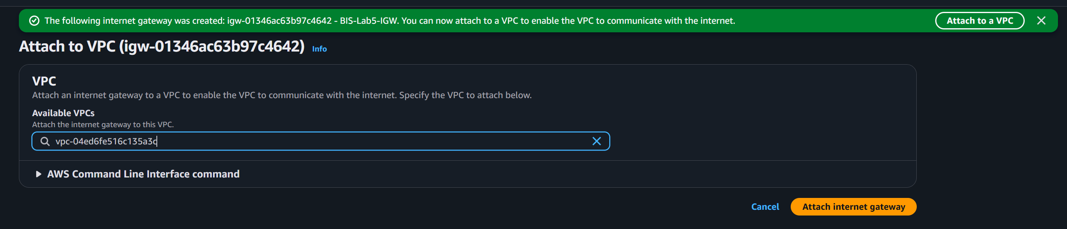

1.8 IGW attached with BIS-Lab5-VPC
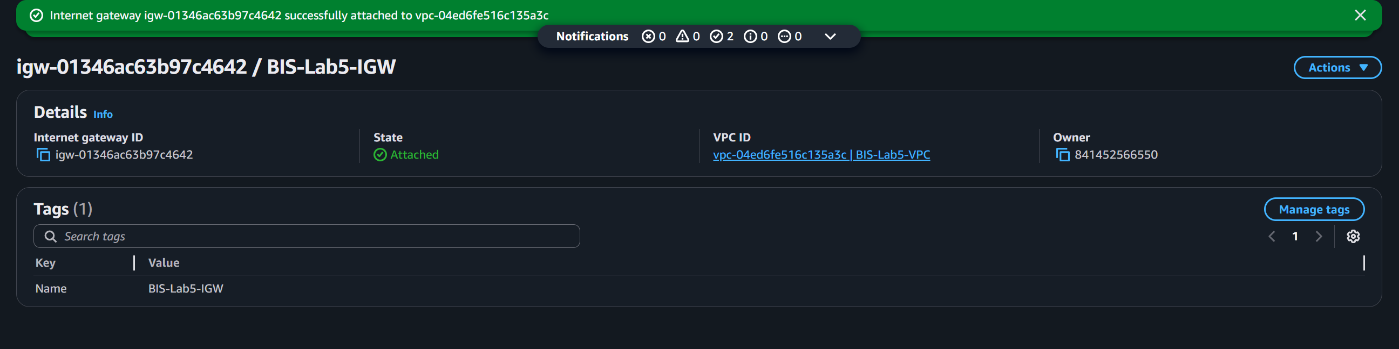

Note: This section confirms the creation of the custom VPC with the CIDR block 10.99.0.0/16 and the successful attachment of an Internet Gateway to provide a path for external connectivity.

Part 2: Creating 6 subnets:

2.1 No subnets before starting this assignment.
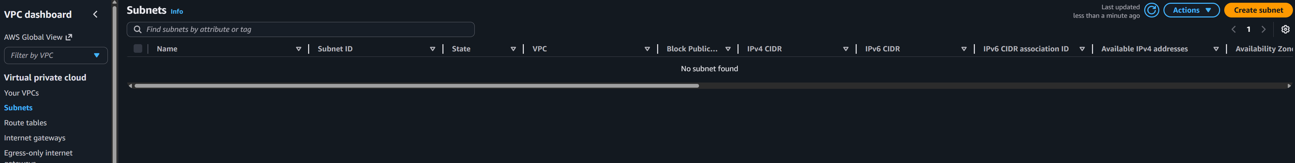

2.2 creating subnets and repeating the process to create all six subnets.
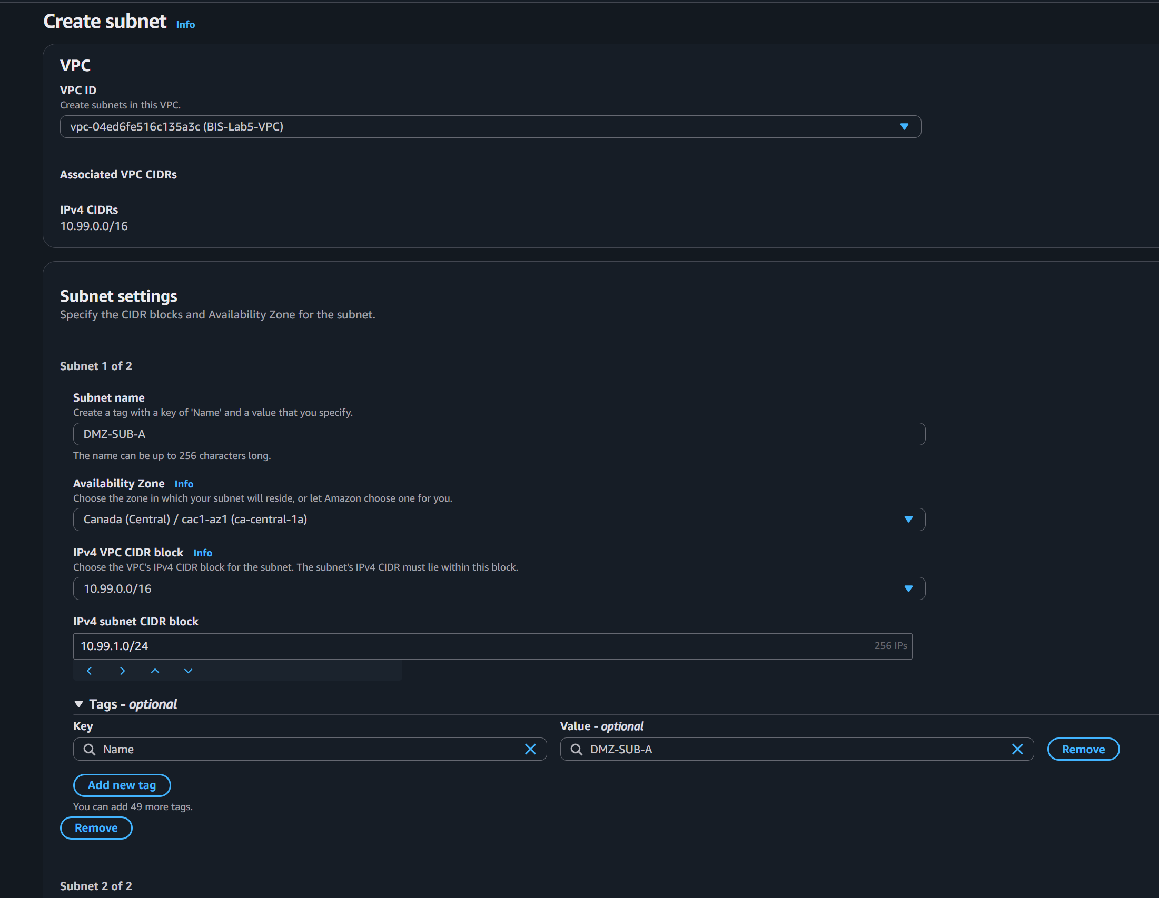
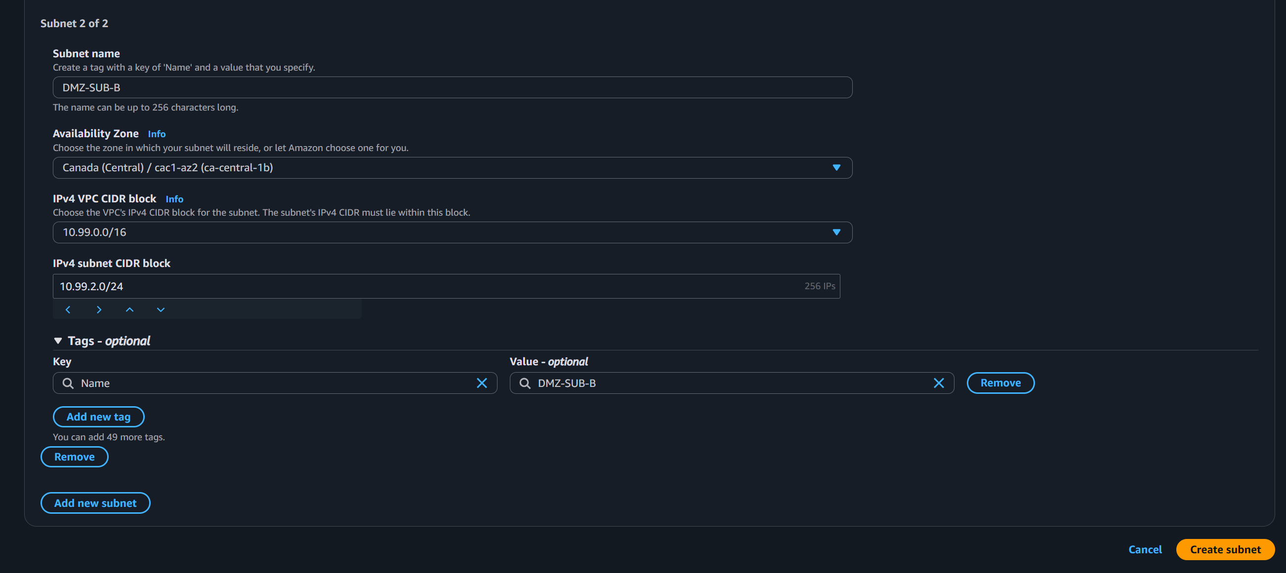

2.3 Six subnets created.
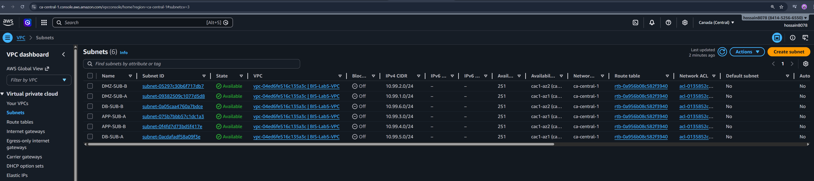
This view displays the six required subnets organized into three layers (DMZ, App, and DB), with each pair strategically split across two different Availability Zones for high availability

Part3- Create NAT Gateway

3.1 No NAT Gateway before starting lab5
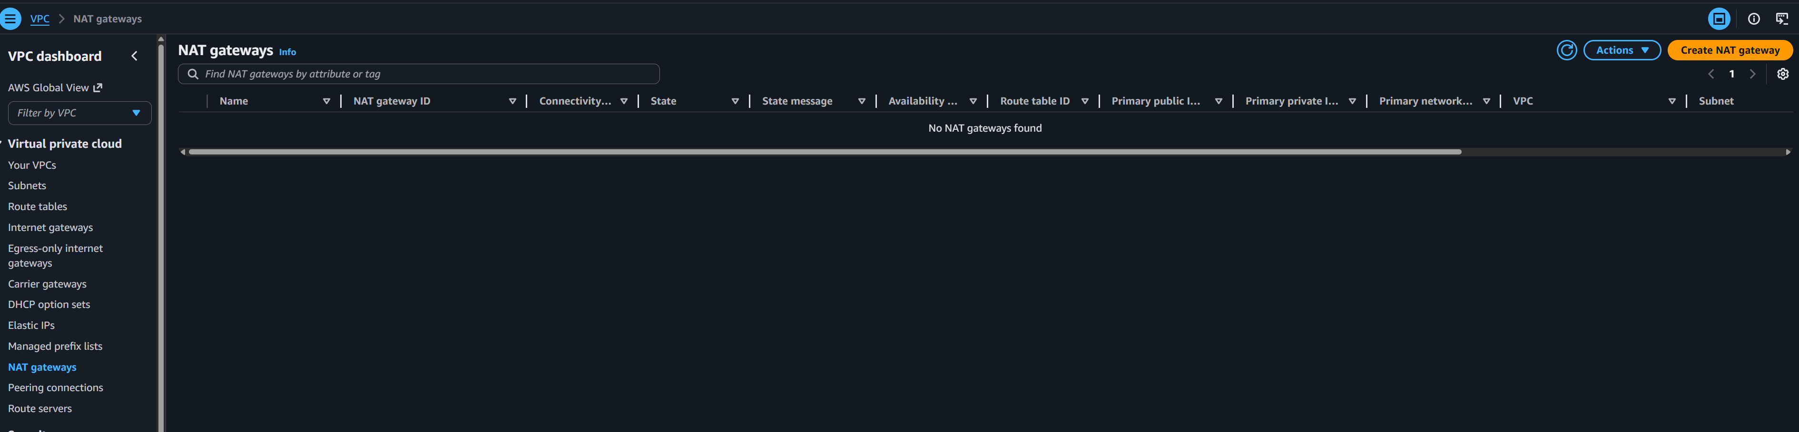

3.2 Creating NAT Gateway
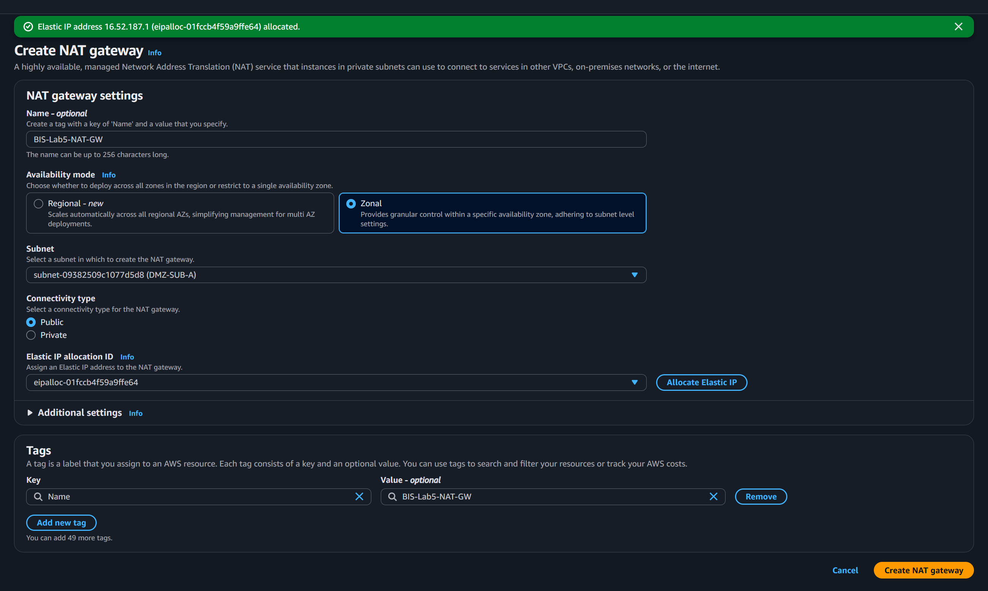

3.3 NAT Gateway created named BIS-Lab5-NAT-GW
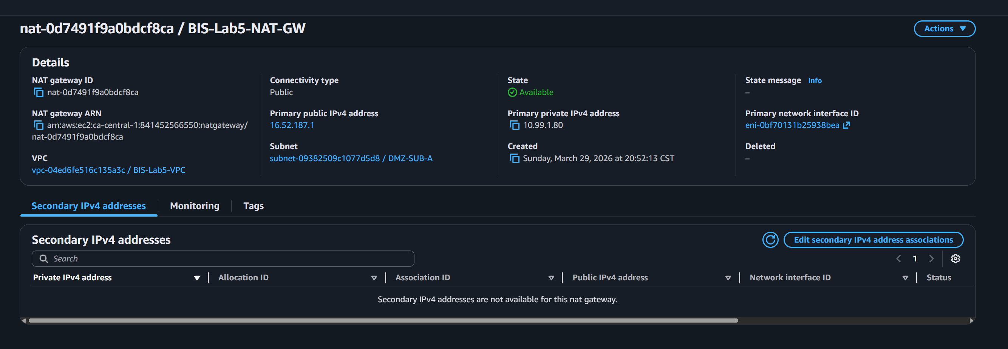

3.4 Configure the Public Route Table (DMZ)
This table allows your "front-door" servers to talk directly to the internet.
- Associated Subnets: DMZ-Subnet-A, DMZ-Subnet-B.
- The Route Rule:
  - Destination: 0.0.0.0/0 (All traffic).
  - Target: igw-01346ac63b97c4642 (My Internet Gateway).
Example: If a user visits your website's public IP, the Internet Gateway passes that traffic to the DMZ subnet because this route table knows how to talk back to the web.

3.4.1 Edit default routing table (BIS-Lab5-PUBRT):
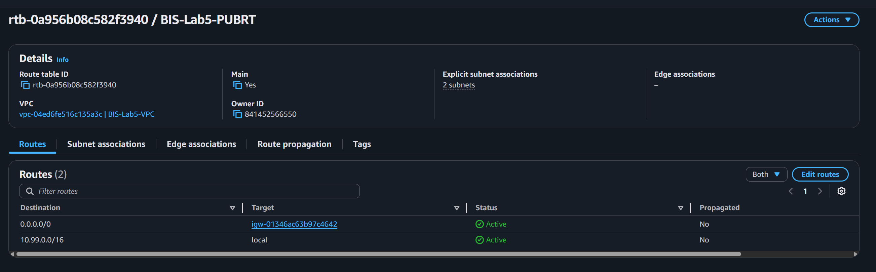

3.4.2 change destination to 0.0.0.0/0 and destination to igw-01346ac63b97c4642 (My Internet Gateway)
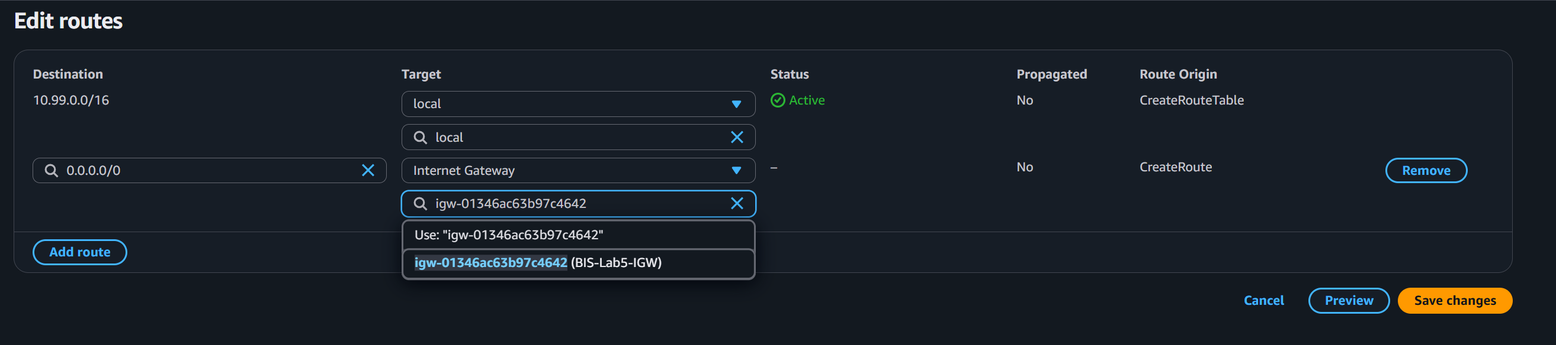

3.4.3 Edit subnet association (DMZ subnets) to associate them with public routing table as it can talk with IGW through public routing table.
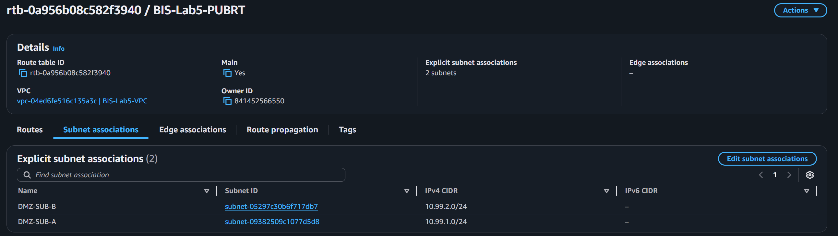

3.5 Configure the Private Route Table (App & DB):
The App and DB layers should not have a direct path to the Internet Gateway; they use the NAT Gateway instead. This table allows your internal servers to reach the internet (for security patches) without being exposed to incoming threats.

- Associated Subnets: App-Subnet-A/B and DB-Subnet-A/B.
- The Route Rule:
  - Destination: 0.0.0.0/0.
  - Target: nat-0d7491f9a0bdcf8ca (My NAT Gateway).
Example: My Database (DBLayer) needs a software update. It sends a request to the NAT Gateway, which masks the DB's private IP and fetches the update from the internet.

3.5.1 Creating routing private routing table named BIS-Lab5-PRIVRT
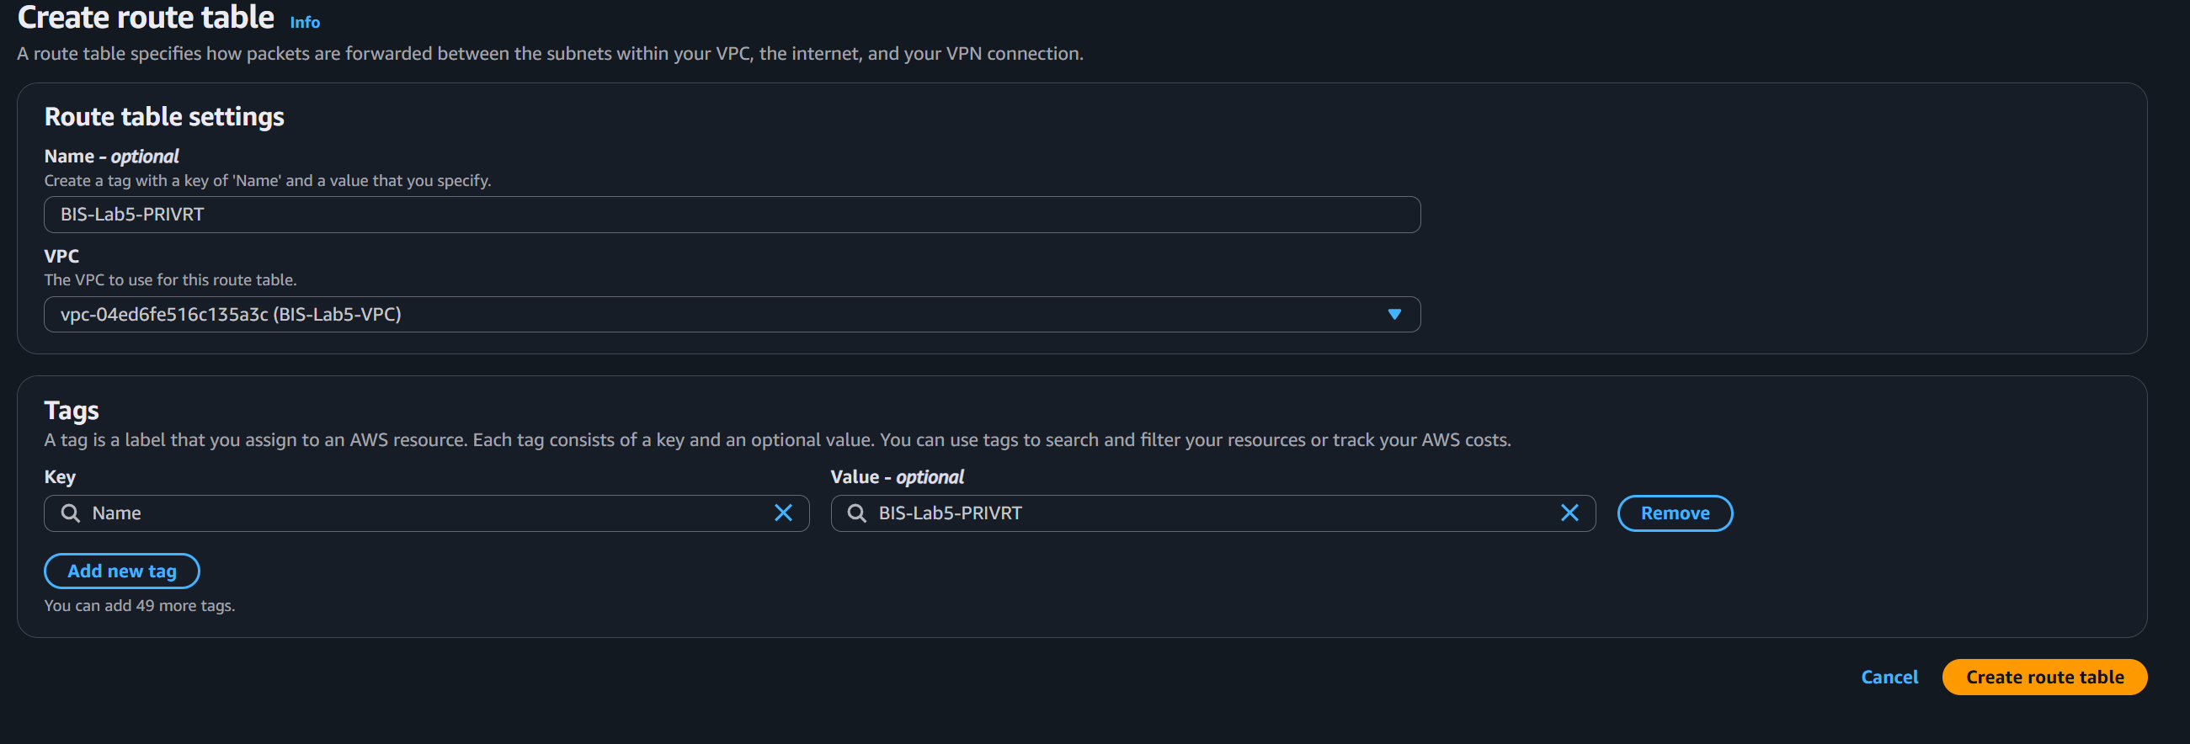

3.5.2 Private routing table created.
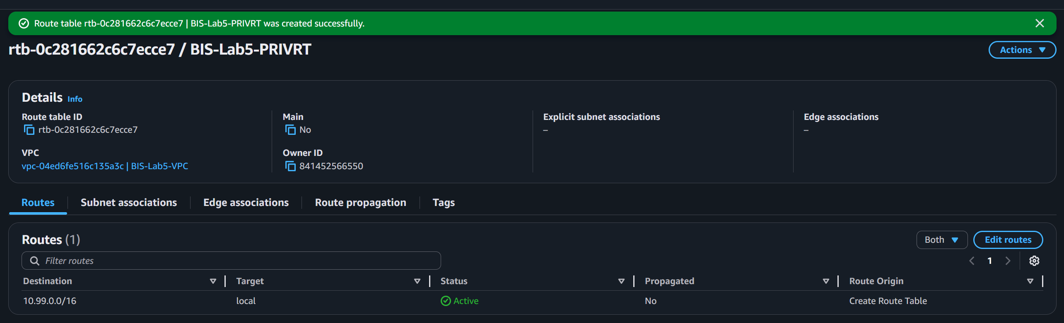

3.5.3 Edit Routes to destination NAT Gateway (nat-0d7491f9a0bdcf8ca).
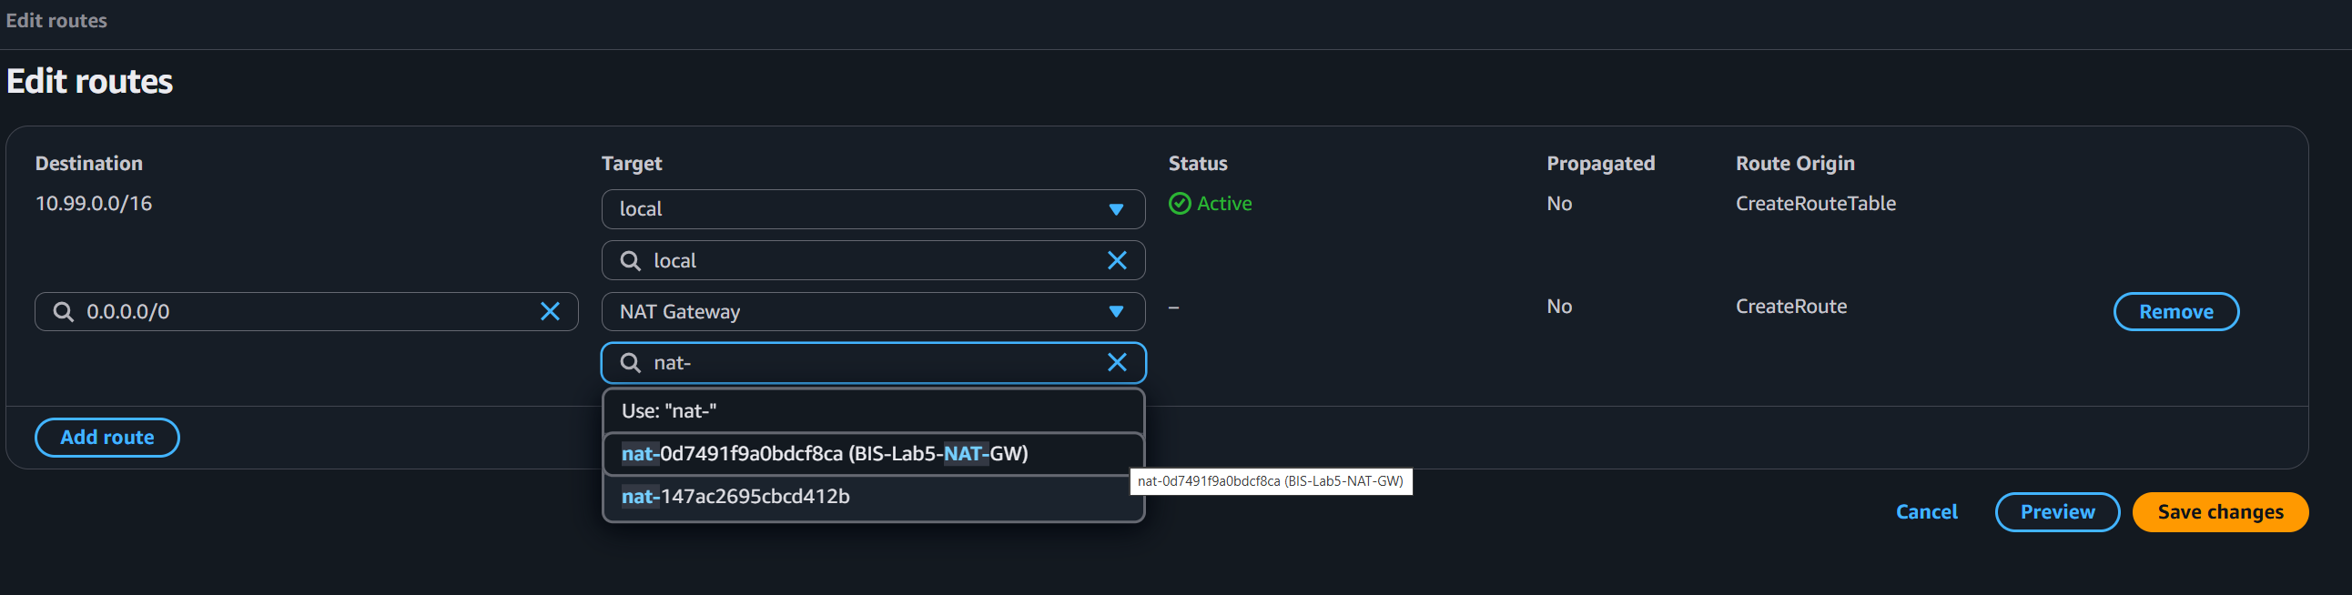

3.5.4 Routes edited for private routing table.
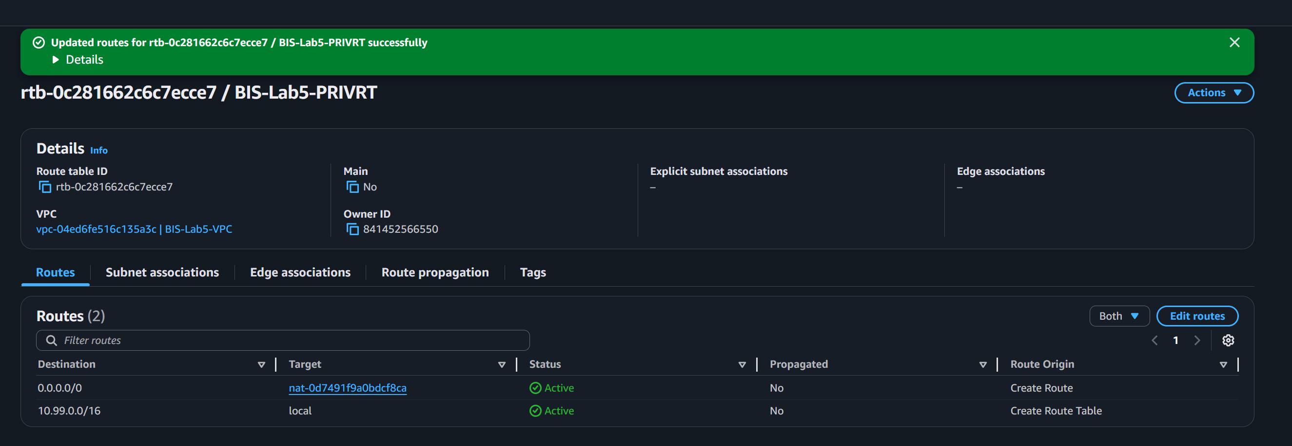

3.5.5 Edit subnet association for remaining network (AppLayer and DBLayer).
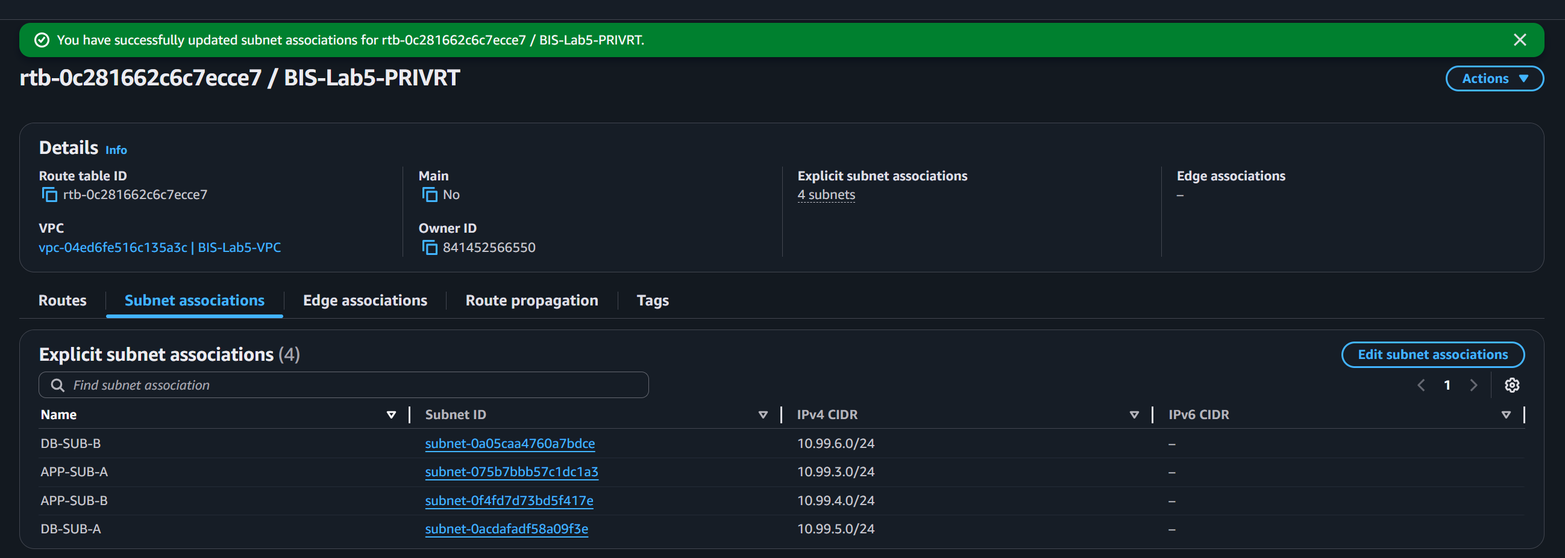

3.5.6 Routing Table Configuration
Layer | Subnet Name | CIDR Block | Routing Table | Route Table Target
DMZ | DMZ-SUB-A | 10.99.1.0/24 | BIS-Lab5-PUBRT (public RT) | Internet Gateway  (igw-01346ac63b97c4642)
DMZ | DMZ-SUB-B | 10.99.2.0/24 | BIS-Lab5-PUBRT (public RT) | Internet Gateway  (igw-01346ac63b97c4642)
APP | APP-SUB-A | 10.99.3.0/24 | BIS-Lab5-PRIVRT (private RT) | NAT Gateway  (nat-0d7491f9a0bdcf8ca)
APP | APP-SUB-B | 10.99.4.0/24 | BIS-Lab5-PRIVRT (private RT) | NAT Gateway  (nat-0d7491f9a0bdcf8ca)
DB | DB-SUB-A | 10.99.5.0/24 | BIS-Lab5-PRIVRT (private RT) | NAT Gateway  (nat-0d7491f9a0bdcf8ca)
DB | DB-SUB-B | 10.99.6.0/24 | BIS-Lab5-PRIVRT (private RT) | NAT Gateway  (nat-0d7491f9a0bdcf8ca)
Note: This section shows the NAT Gateway configured within a public DMZ subnet, complete with an assigned Elastic IP to allow private instances in the App and DB layers to securely access the internet for updates.

Part 4: Creating NACLs

4.1 Creating DMZ NACL for Demilitarized Zone subnets
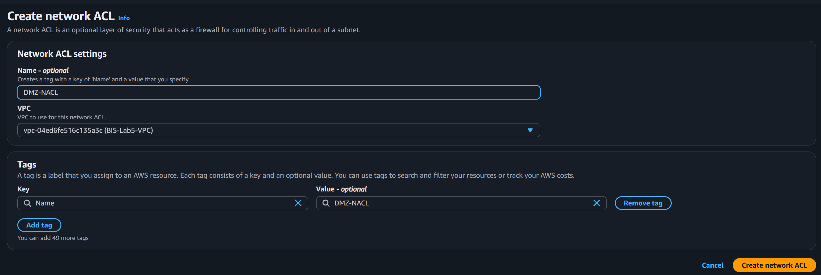

4.2 Creating App-NACL for AppLayer subnets
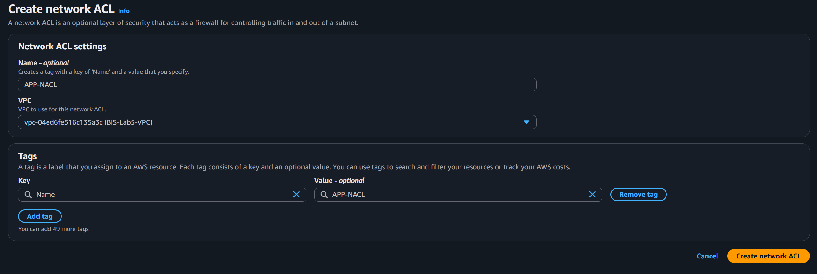

4.3 Creating DB-NACL for DBLayer subnets.
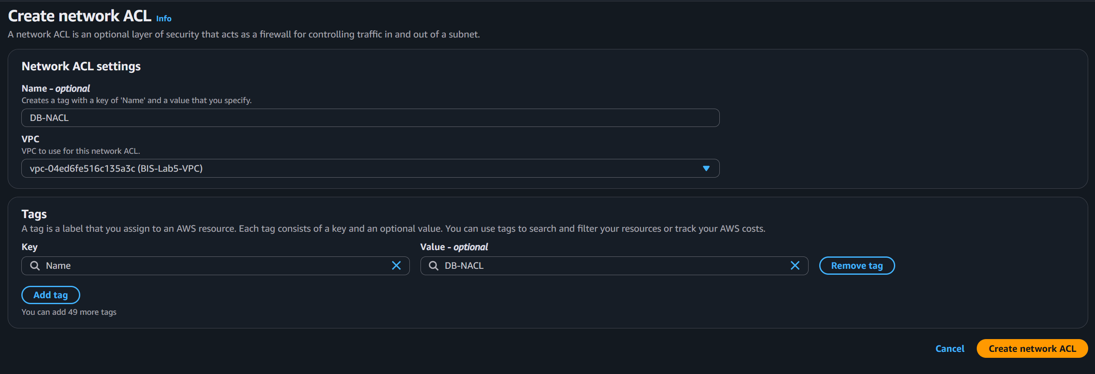

4.4 All NACL before editing subnet association.
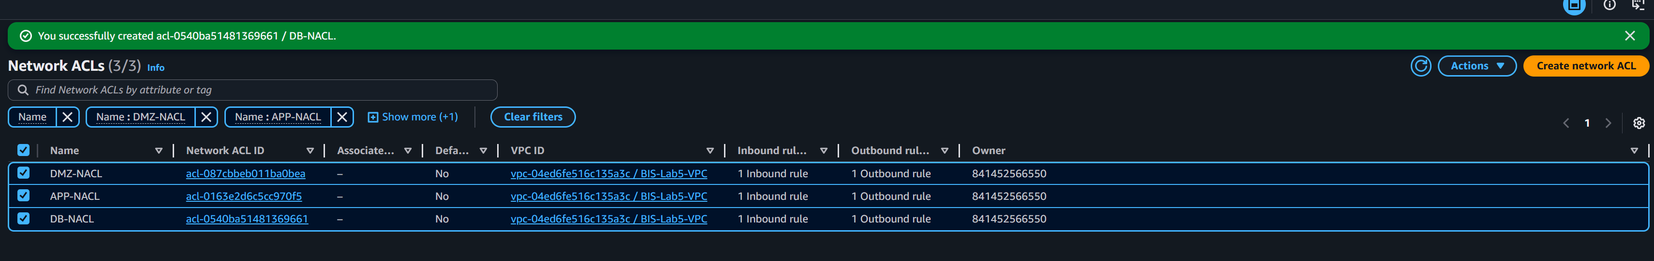

Part 5: Subnet Association with NACL

5.1 Associated DMZ-NACL with DMZ Subnets.
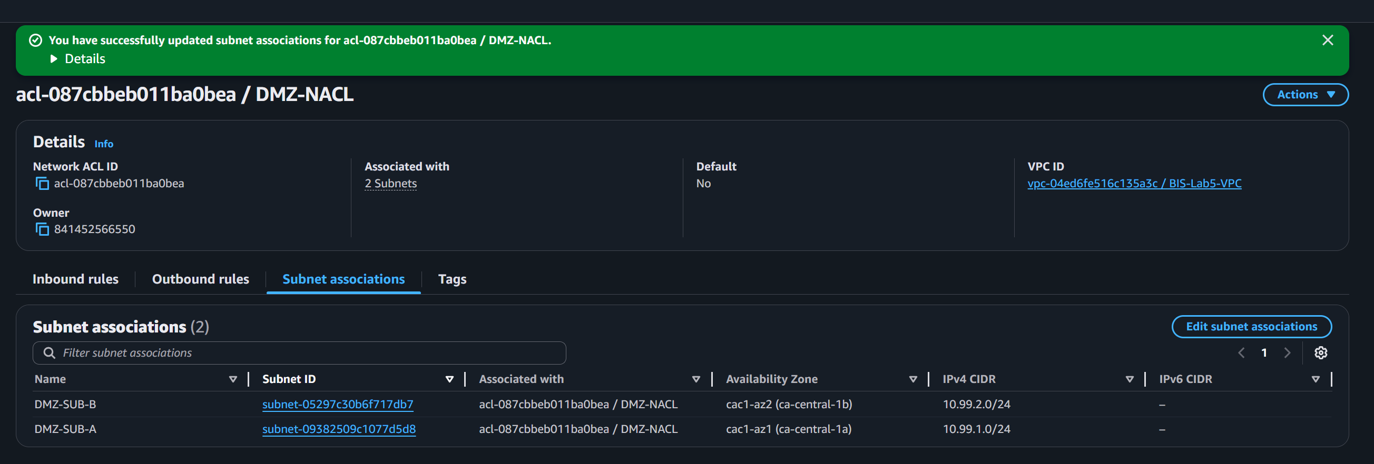

5.2 Associated APP-NACL with APP subnets.
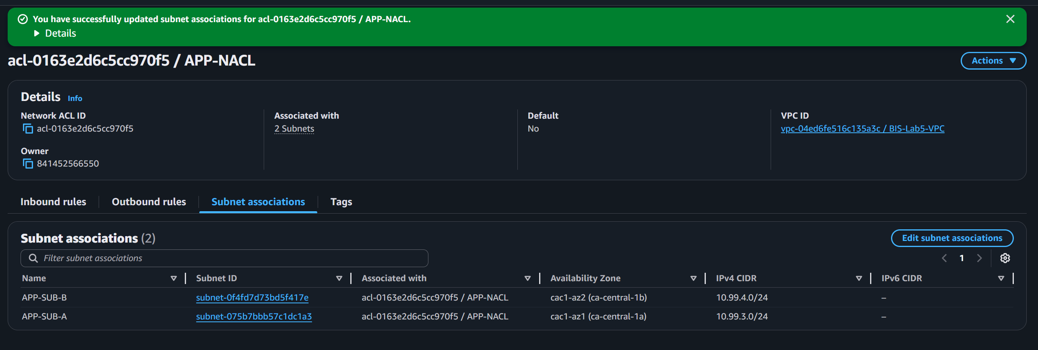

5.3 associated DB-NACL with DB subnets.
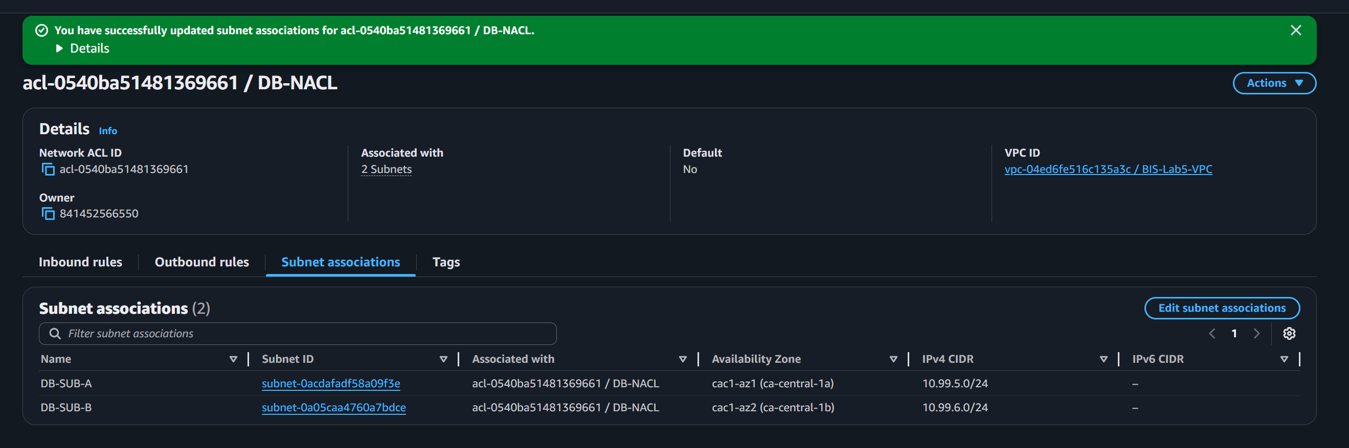
Note: This section captures the three distinct Network ACLs created to act as stateless firewalls, providing dedicated security layers for the DMZ, Application, and Database tiers.

Part 6: Questions and Answers
1. What are the security benefits of the VPC design?
The primary security benefit is Defense in Depth through multi-layered isolation.
- Traffic Control: By using three distinct Network ACLs (NACLs) associated with specific subnet groupings (DMZ, AppLayer, and DBLayer), we can define strict rules for what traffic is allowed to enter or leave each tier.
- Resource Isolation: Sensitive components like the database are placed in subnets that lack a direct route to the Internet Gateway, physically preventing external actors from initiating connections to them.
- Controlled Outbound Access: Using a NAT Gateway allows private instances to securely access the internet for updates without revealing their private IP addresses to the public web.
2. What might this type of VPC architecture be well suited to?
This architecture is ideal for a Standard 3-Tier Web Application.
- E-commerce Sites: The DMZ handles public web traffic, the AppLayer processes business logic (like shopping carts), and the DBLayer stores customer and inventory data securely.
- Banking or Healthcare Portals: Applications requiring high levels of data privacy where the backend database must be strictly shielded from the public-facing interface.
3. What is the purpose of a DMZ?
The DMZ (Demilitarized Zone) serves as a secure buffer between the public internet and our private internal network.
- Public Interface: It hosts resources that must be reachable from the internet, such as Load Balancers or Web Servers.
- Risk Mitigation: It ensures that if a front-end server is compromised, the attacker is still separated from the critical Application and Database layers by additional firewalls (NACLs) and private networking.
4. Why is the DB subnet on a non-internet-connected subnet?
The database contains the most sensitive information and should never be directly accessible from the outside.
- Attack Surface Reduction: By removing a direct route to the Internet Gateway, we eliminate the possibility of "Brute Force" or "SQL Injection" attacks originating directly from the public internet.
- One-Way Connectivity: The DB only needs to communicate with the AppLayer; any necessary internet communication (like software patches) is handled through the NAT Gateway, which only allows "egress" (outbound) traffic.
5. Why might you want to use a multi-availability zone architecture?
A Multi-AZ architecture is used to ensure High Availability and Fault Tolerance.
- Redundancy: By splitting each pair of subnets (DMZ, App, DB) across different Availability Zones (AZs), we can ensure that our application remains functional even if one AWS data center experiences a failure.

Example: If we have App-Subnet-A in AZ-1 and App-Subnet-B in AZ-2, and a power outage strikes AZ-1, our traffic will automatically shift to the healthy instances in AZ-2, resulting in zero downtime for our users.

